Scenario Topic Name Bank of Anvil – Loan Application Tracker

- Scenario and Example Queries

  - Scenario (100 words maximum)

This database models the loan application lifecycle for a fictional institution, Bank of Anvil.

The system captures six entities: a customer who holds a bank_account, submits a loan application (action entity), which is reviewed by an underwriter and recorded as a loan decision.

Approved loans generate an active credit line, linked to the customer's account.
Entries in application progress through three stages, pending, in_review, and completed.
They are then recorded as either approved or rejected in loan. This design captures the full operational workflow of a retail banking loan process, from customer through to credit issuance.

  - Example queries (Minimum 5 – list, who, which, how many, most, fewest, etc. - check that your models have the attributes needed to answer the queries)

1)
Query – How many customers of the bank has a credit application vs credit line?
Uses credit_status and COUNT to group customers by status.
Attributes needed: customer.credit_status, customer.customer_id
SELECT credit_status, COUNT(customer_id) AS total_credit_status
FROM customer
Group By credit_status;

2)
Query - Which underwriter has reviewed the most applications?
Uses JOIN on underwriter_id and COUNT to rank underwriters by decisions made.
Attributes needed: underwriter.first_name, underwriter.underwriter_id, loan.loan_id, loan.underwriter_id
SELECT underwriter.first_name, COUNT(loan.loan_id) AS Number_Of_Applications_Reviewed
FROM underwriter
JOIN loan ON underwriter.underwriter_id = loan.underwriter_id
Group By underwriter.first_name
ORDER BY Number_Of_Applications_Reviewed DESC;

3)
Query - How many applications are currently pending vs in-review vs completed?
Uses status and COUNT to group applications by current stage.
Attributes needed: application.status, application.application_id
SELECT status, COUNT(application_id) AS applications_status
FROM application
Group By status;

4)
Query - What is the highest, lowest, and total credit requested across all applications?
Uses MAX, MIN and SUM on amount to summarise credit requested.
Attributes needed: application.amount
SELECT MAX(amount) AS highest_credit_requested, MIN(amount) AS lowest_credit_requested, SUM(amount) AS sum_of_credit_requested
FROM application;

5)
Query - Which branch has reviewed the most applications?
Uses JOIN on underwriter_id and COUNT to rank branches by decisions made.
Attributes needed: underwriter.branch, underwriter.underwriter_id, loan.loan_id, loan.underwriter_id
SELECT underwriter.branch, COUNT(loan.loan_id) AS Number_Of_Applications_Per_Branch
FROM underwriter
JOIN loan ON underwriter.underwriter_id = loan.underwriter_id
Group By underwriter.branch
ORDER BY Number_Of_Applications_Per_Branch DESC;

6)
Query — How many loans were approved vs rejected historically?
Uses decision and COUNT to summarise historical approval and rejection rates.
Attributes needed: loan.decision, loan.loan_id
SELECT decision, COUNT(loan_id) AS total_historical_data
FROM loan
Group By decision;

7)
Query — What is the average repayment rate across all credit lines?
Uses a calculated ratio to show how much of the balance is being paid monthly, giving insight into repayment behaviour.
Attributes needed: credit_line.balance_due, credit_line.monthly_payment, credit_line.credit_id
SELECT COUNT(credit_id) AS total_credit_lines, SUM(balance_due) AS total_balance, AVG(monthly_payment) AS avg_monthly_payment, ROUND(AVG(monthly_payment / NULLIF(balance_due, 0)) * 100, 2) AS avg_repayment_rate_pct
FROM credit_line;

- Entity Relationship (ER) Model

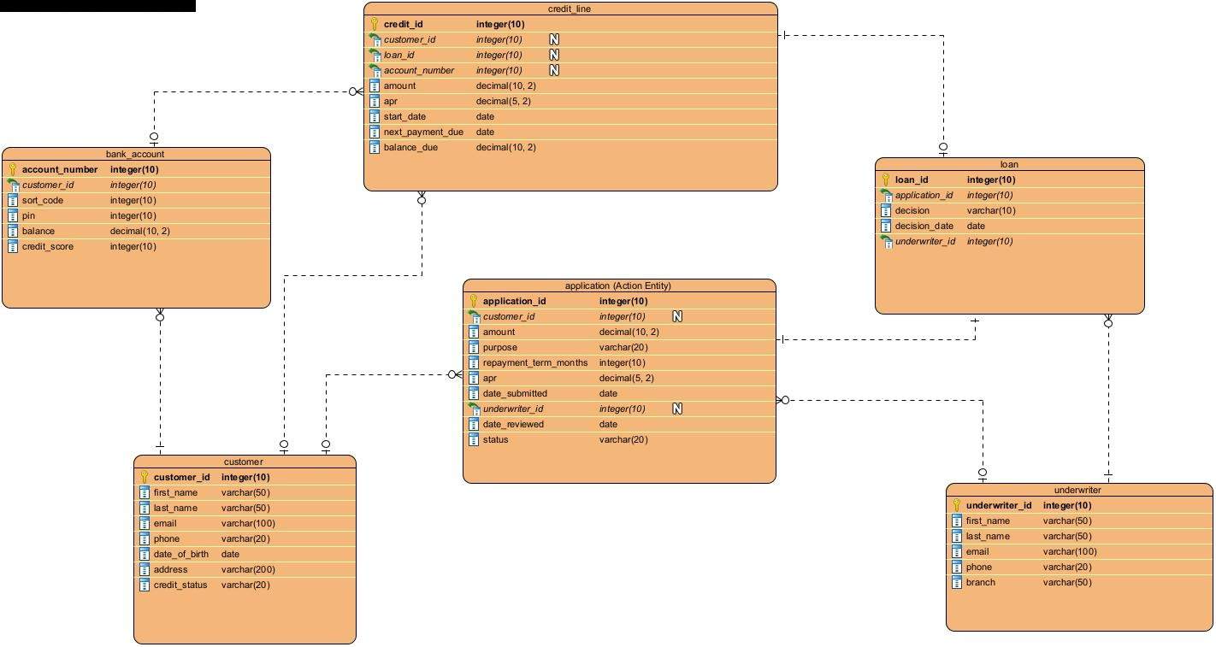

customer
Primary Key: customer_id
Relationships:
- customer → bank_account = 1..*
- customer → application = 0..*
- customer → credit_line = 0..*
A customer must have at least one account but may or may not have loan applications or credit lines.

bank_account
Primary Key: account_number
Foreign Key: customer_id → customer
Relationships:
- bank_account → customer = 1..1
- bank_account → credit_line = 0..*
Each account belongs to one customer and may be linked to credit lines.

application (Action Entity)
Primary Key: application_id
Foreign Keys: customer_id → customer, underwriter_id → underwriter
Relationships:
- application → customer = 1..1
- application → underwriter = 0..1
- application → loan = 0..1
Every application belongs to one customer, will at some point be assigned to an underwriter during review, ALWAYS results in exactly one loan record (decision outcome).

underwriter
Primary Key: underwriter_id
Relationships:
- underwriter → application = 0..*
- underwriter → loan = 0..*
Underwriters may review many applications and make many loan decision.

loan
Primary Key: loan_id
Foreign Keys: application_id → application, underwriter_id → underwriter
Relationships:
- loan → application = 1..1
- loan → underwriter = 1..1
- loan → credit_line = 0..1
Every loan represents the final decision (approved or rejected), is linked to exactly one application, is made by exactly one underwriter, may generate a credit line only if approved.

credit_line
Primary Key: credit_id
Foreign Keys: customer_id → customer, loan_id → loan, account_number → bank_account
Relationships:
- credit_line → loan = 1..1
- credit_line → customer = 1..1
- credit_line → bank_account = 1..1
Only approved loans create credit lines. Rejected loans do not generate any credit line.

- Relational Model Tables

  - Relational Model Tables
- Copy and paste the table below for as many relational tables as you need.
- Replace the placeholder names (Table_name, Attribute_name1-Attribute_name4, Datatype1-Datatype4, etc) with the table and attribute names and their datatypes you derived from your ER model.
- List the primary key attribute first, defining it using PRIMARY KEY.
- Add attribute rows to the tables as needed.
- Delete any unnecessary rows (attribute rows and foreign key rows if not used).
- Foreign keys are to be specified in the format ‘FOREIGN KEY (Attribute_name) REFERENCES Table_name (Attribute_name).

Relational table specification
Table name: customer
Attributes
customer_id integer(10) PRIMARY KEY
first_name varchar(50)
last_name varchar(50)
email varchar(100)
phone varchar(20)
date_of_birth date
address varchar(200)
credit_status varchar(20)
PRIMARY KEY (customer_id)

Relational table specification
Table name: bank_account
Attributes
account_number integer(10) PRIMARY KEY
customer_id integer(10)
sort_code integer(10)
pin integer(10)
balance decimal(10,2)
credit_score integer(10)
PRIMARY KEY (account_number)
FOREIGN KEY (customer_id) REFERENCES customer (customer_id)

Relational table specification
Table name: underwriter
Attributes
underwriter_id integer(10) PRIMARY KEY
first_name varchar(50)
last_name varchar(50)
email varchar(100)
phone varchar(20)
branch varchar(50)
PRIMARY KEY (underwriter_id)

Relational table specification
Table name: application
Attributes
application_id integer(10) PRIMARY KEY
customer_id integer(10)
amount decimal(10,2)
purpose varchar(20)
repayment_term_months integer(10)
apr decimal(5,2)
date_submitted date
underwriter_id integer(10)
date_reviewed date
status varchar(20)
PRIMARY KEY (application_id)
FOREIGN KEY (customer_id) REFERENCES customer (customer_id)
FOREIGN KEY (underwriter_id) REFERENCES underwriter (underwriter_id)

Relational table specification
Table name: loan
Attributes
loan_id integer(10) PRIMARY KEY
application_id integer(10)
decision varchar(10)
decision_date date
underwriter_id integer(10)
PRIMARY KEY (loan_id)
FOREIGN KEY (application_id) REFERENCES application (application_id)
FOREIGN KEY (underwriter_id) REFERENCES underwriter (underwriter_id)

Relational table specification
Table name: credit_line
Attributes
credit_id integer(10) PRIMARY KEY
customer_id integer(10)
loan_id integer(10)
account_number integer(10)
amount decimal(10,2)
apr decimal(5,2)
repayment_term_months integer(10)
monthly_payment decimal(10,2)
start_date date
next_payment_due date
balance_due decimal(10,2)
PRIMARY KEY (credit_id)
FOREIGN KEY (customer_id) REFERENCES customer (customer_id)
FOREIGN KEY (loan_id) REFERENCES loan (loan_id)
FOREIGN KEY (account_number) REFERENCES bank_account (account_number)

  - Relational Model Tables with Values

- Copy and paste the table below for as many relational tables as you need.
- Replace the placeholder names (Table_name) with the table names you derived from your ER model.
- Replace the placeholder names (Attribute_name1-Attribute_name4, and Value1-Value5, etc) with the table names you derived from your ER model.
- At least 5 rows of values should be inserted for each table.

Relational table with Values specification
INSERT INTO customer VALUES
(4821, 'James', 'Carter', 'james.carter@email.com', '07911123456', '1990-03-15', '12 Maple Street, London', 'credit_line'),
(7364, 'Sofia', 'Patel', 'sofia.patel@email.com', '07922234567', '1985-07-22', '34 Oak Avenue, Birmingham', 'credit_line'),
(2947, 'Marcus', 'Webb', 'marcus.webb@email.com', '07933345678', '1992-11-08', '56 Pine Road, Manchester', 'application'),
(6183, 'Aisha', 'Okonkwo', 'aisha.okonkwo@email.com', '07944456789', '1988-04-30', '78 Elm Close, Leeds', 'credit_line'),
(5529, 'Daniel', 'Hughes', 'daniel.hughes@email.com', '07955567890', '1995-09-14', '90 Birch Lane, Bristol', 'application'),
(8834, 'Olivia', 'Grant', 'olivia.grant@email.com', '07966678901', '1993-06-18', '23 Cedar Drive, Edinburgh', 'credit_line');

Relational table with Values specification
INSERT INTO bank_account VALUES
(63847291, 4821, 200415, 1234, 5200.00, 720),
(91023748, 7364, 200416, 5678, 12400.00, 810),
(47382910, 2947, 200417, 9012, 3100.00, 650),
(82947361, 6183, 200418, 3456, 8750.00, 780),
(39018472, 5529, 200419, 7890, 1500.00, 590),
(57291846, 8834, 200420, 4321, 3750.00, 698);

Relational table with Values specification
INSERT INTO underwriter VALUES
(3847, 'Rachel', 'Monroe', 'r.monroe@bankofanvil.com', '02071234567', 'London'),
(7291, 'Thomas', 'Blake', 't.blake@bankofanvil.com', '01212345678', 'Birmingham'),
(5618, 'Priya', 'Shah', 'p.shah@bankofanvil.com', '01613456789', 'Manchester'),
(9034, 'Connor', 'Reid', 'c.reid@bankofanvil.com', '01134567890', 'Leeds'),
(2473, 'Laura', 'Simmons', 'l.simmons@bankofanvil.com', '01175678901', 'Bristol'),
(6612, 'James', 'Fletcher', 'j.fletcher@bankofanvil.com', '01314567890', 'Edinburgh');

Relational table with Values specification
INSERT INTO application VALUES
(6284, 4821, 15000.00, 'Home Improvement', 36, 6.50, '2024-01-10', 3847, '2024-01-15', 'completed'),
(3917, 7364, 8000.00, 'Debt Consolidation', 24, 7.20, '2024-01-12', 7291, '2024-01-18', 'completed'),
(1729, 6183, 5000.00, 'Vehicle Purchase', 12, 5.90, '2024-02-05', 3847, '2024-02-10', 'completed'),
(7731, 4821, 10000.00, 'Education', 48, 5.50, '2024-03-01', 7291, '2024-03-07', 'completed'),
(3382, 7364, 6000.00, 'Medical Expenses', 12, 6.80, '2024-03-05', 9034, '2024-03-12', 'completed'),
(4471, 8834, 12000.00, 'Home Improvement', 24, 7.10, '2024-04-01', 6612, '2024-04-07', 'completed'),
(8453, 2947, 25000.00, 'Business Loan', 60, 8.10, '2024-02-01', 5618, NULL, 'in_review'),
(5096, 5529, 3000.00, 'Personal Loan', 18, 9.00, '2024-02-08', NULL, NULL, 'pending');

Relational table with Values specification
INSERT INTO loan VALUES
(7392, 6284, 'approved', '2024-01-15', 3847),
(4817, 3917, 'approved', '2024-01-18', 7291),
(2638, 1729, 'approved', '2024-02-10', 3847),
(8821, 7731, 'approved', '2024-03-07', 7291),
(4463, 3382, 'rejected', '2024-03-12', 9034),
(3349, 4471, 'approved', '2024-04-07', 6612);

Relational table with Values specification
INSERT INTO credit_line VALUES
(1047, 4821, 7392, 63847291, 15000.00, 6.50, 36, 416.67, '2024-01-15', '2024-02-15', 15000.00),
(2389, 7364, 4817, 91023748, 8000.00, 7.20, 24, 333.33, '2024-01-18', '2024-02-18', 8000.00),
(5692, 6183, 2638, 82947361, 5000.00, 5.90, 12, 416.67, '2024-02-10', '2024-03-10', 5000.00),
(7815, 4821, 8821, 63847291, 10000.00, 5.50, 48, 208.33, '2024-03-07', '2024-04-07', 10000.00),
(9026, 8834, 3349, 57291846, 12000.00, 7.10, 24, 500.00, '2024-04-07', '2024-05-07', 12000.00);

- Querying a Database

- Type your 5 example queries below.
- Also, show the results they obtained, for which you can take a screenshot of it from the phpMyAdmin tool and show it as an image.

1)
Query – How many customers of the bank has a credit application vs credit line?
Uses credit_status and COUNT to group customers by status.
SELECT credit_status, COUNT(customer_id) AS total_credit_status
FROM customer
Group By credit_status;

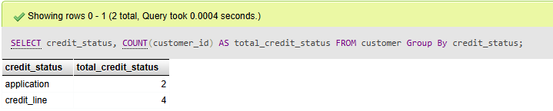

2)
Query - Which underwriter has reviewed the most applications?
Uses JOIN on underwriter_id and COUNT to rank underwriters by decisions made.
SELECT underwriter.first_name, COUNT(loan.loan_id) AS Number_Of_Applications_Reviewed
FROM underwriter
JOIN loan ON underwriter.underwriter_id = loan.underwriter_id
Group By underwriter.first_name
ORDER BY Number_Of_Applications_Reviewed DESC;

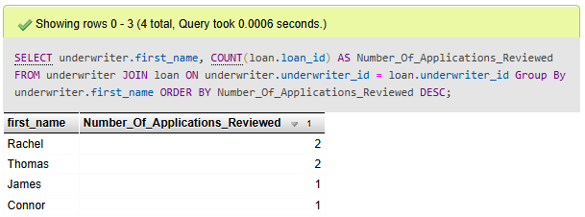

3)
Query - How many applications are currently pending vs in-review vs completed?
Uses status and COUNT to group applications by current stage.
SELECT status, COUNT(application_id) AS applications_status
FROM application
Group By status;

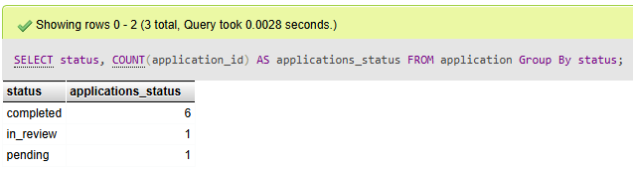

4)
Query - What is the highest, lowest, and total credit requested across all applications?
Uses MAX, MIN and SUM on amount to summarise credit requested.
SELECT MAX(amount) AS highest_credit_requested, MIN(amount) AS lowest_credit_requested, SUM(amount) AS sum_of_credit_requested
FROM application;

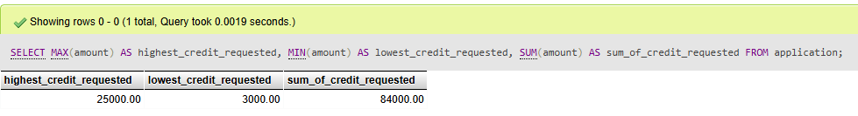

5)
Query - Which branch has reviewed the most applications?
Uses JOIN on underwriter_id and COUNT to rank branches by decisions made.
SELECT underwriter.branch, COUNT(loan.loan_id) AS Number_Of_Applications_Per_Branch
FROM underwriter
JOIN loan ON underwriter.underwriter_id = loan.underwriter_id
Group By underwriter.branch
ORDER BY Number_Of_Applications_Per_Branch DESC;
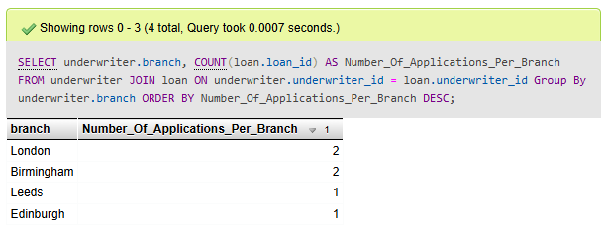

6)
Query — How many loans were approved vs rejected historically?
Uses decision and COUNT to summarise historical approval and rejection rates.
SELECT decision, COUNT(loan_id) AS total_historical_data
FROM loan
Group By decision;

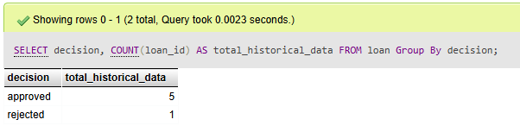

7)
Query — What is the average repayment rate across all credit lines?
Uses a calculated ratio to show how much of the balance is being paid monthly, giving insight into repayment behaviour.
SELECT COUNT(credit_id) AS total_credit_lines, SUM(balance_due) AS total_balance, AVG(monthly_payment) AS avg_monthly_payment, ROUND(AVG(monthly_payment / NULLIF(balance_due, 0)) * 100, 2) AS avg_repayment_rate_pct
FROM credit_line;

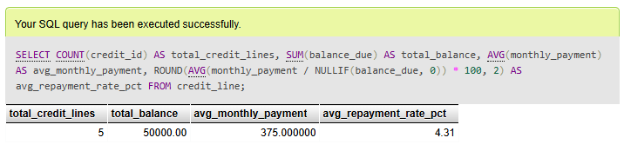

- Discuss the idea of storing data with a non-relational database (350 words maximum)

I believe the Bank of Anvil Loan Application Tracker could work well within a non-relational database. The MongoDB would be the most suitable fit, as it stores data in flexible JSON-like documents that can hold nested structures and varying attributes depending on what each record needs.

In the current relational design, getting a complete picture of a single customer's loan journey requires joining across multiple normalised tables (customer, bank_account, application, loan, and credit_line), all connected through foreign keys. With MongoDB, that entire lifecycle could live inside one customer document, which makes customer-focused queries significantly faster and simpler to write.

For example, a customer document could hold their personal details and account information, alongside an array of their applications. Each application could carry attributes like amount, purpose, and status, with a nested loan object representing the underwriter's decision and decision date. If the loan was approved, a further embedded credit line object could store the balance, APR, and repayment details capturing the full journey in one place without join.

There are drawbacks that must be considered, underwriter data would either need to be embedded in every customer document, which leads to duplication, or stored separately and referenced, which creates a lot of relational complexity.

There is also the question of data integrity. MongoDB does not enforce referential integrity natively, so constraints that a relational database handles automatically would need to be managed at the application level instead. And while MongoDB does support transactions, relational systems offer stronger and more mature ACID guarantees which in a financial system like this one, is necessary.

Overall, MongoDB offers genuine benefits in flexibility and retrieval speed, but the need for strong consistency and reliable transaction processing makes the relational approach the better choice for Bank of Anvil.

